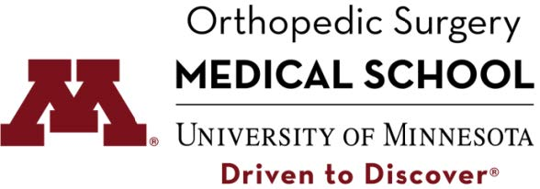

Visiting Medical Student Scholarship for Underrepresented Minorities in Orthopedic Surgery

The University of Minnesota is committed to achieving excellence through equity and diversity. We value having diverse views and experiences that enrich our academics and our profession as a whole. The Department of Orthopedic Surgery, in conjunction with the Medical School, has the goal of creating an atmosphere where differences are valued, leading to a culturally competent healthcare workforce qualified to meet the needs of the varied populations we serve.

Our scholarship provides financial assistance for upcoming 3rd^{rd} and 4th^{th} year medical students (class of 2021 and 2022) who are planning a career in orthopedic surgery, and want to do a four-week away rotation at our site. Diverse students whose backgrounds and/or identities are underrepresented in orthopedics are encouraged to apply. The chosen applicants will be given a stipend of $1,000 to be used towards their lodging and/or travel expenses.

Once the application deadline has passed, five scholarship applicants will be selected to be interviewed. Two applicants will be selected for the scholarship for the 2020-2021 academic year.

To fill out an application for this scholarship click here.

Requirements:
- Must be an upcoming 3rd^{rd} or 4th^{th} year medical student
- Attend a domestic LCME-accredited medical school
- Provide a current CV
- Upload an official transcript
- Letter of recommendation from a professional reference who can speak to your goals and academic experience (One letter of recommendation only)
- Provide a personal statement addressing how you contribute to diversity in orthopedics
- Provide Step 1 score by uploading an USMLE unofficial transcript
- Skype interview; If selected as a top five candidate

Selection will be based on a holistic approach. Students’ academic achievements, shown leadership, academic research, orthopedic interest, and good academic standings will all be considered when selecting candidates.

Application opens on September 1st, 2019.
Deadline for all applications for 2020-2021 academic year are due by December 1, 2019.

If you have any questions regarding this scholarship please contact,
Alyssa Boos at boosx015@umn.edu

